Lakshmi Narain College of Technology & Science, Bhopal

Department of Electronics and Communication Engineering

Name: MAdhuri Darkar Enrolment no.:0157EC181048 Class: EC V D

Date: 27/08/20 Page no.: 13

**PRACTICAL-4**

Aim: Write a scilab code to show the marks of ten students in bar graph.

Software required: Scilab version 6.0.2

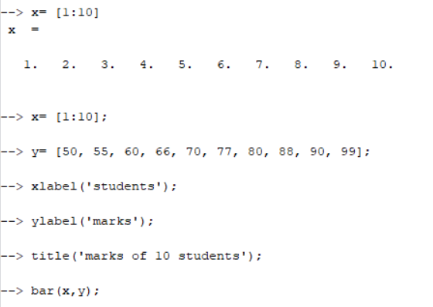

The graph for the above code is plotted on the graphic window as shown below:

Lakshmi Narain College of Technology & Science, Bhopal

Department of Electronics and Communication Engineering

Name: Madhuri Darkar Enrolment no.:0157EC181048 Class: EC V D

Date: 27/08/20 Page no.: 14

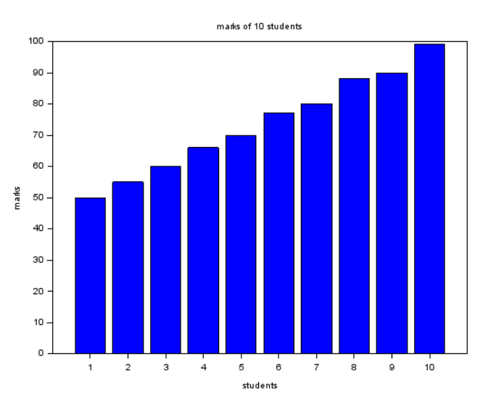

Result: Hence study of bar plot successfully performed.

Teacher’s signature